*Discover the “Secret Formula” that the Most   
Successful Use to Fuel Growth and Outperform the Competition*

The 4 Proven Marketing Systems That Will Ensure 25 Percent Growth *Or More* at Your Business In The Next 12 Months!

How Companies Just Like Yours Focus on These 4 Systems to Dominate Their Market!

**(Psst! Write in this book!)**

This is your copy, so feel free to highlight, underline, and take notes.   
You won’t get in trouble—we promise!

# Welcome

What I’m about to show you can ignite growth at your business well beyond the levels you’ve likely achieved in the past.

How do I know this is true?

Because 95 percent of the clients I have worked with over the years are missing AT LEAST two out of the four critical, proven marketing systems that are necessary to achieve maximum business growth.

And the clients who are leveraging all four?

They’re growing.

*Fast*.

So unless your situation is completely out of the ordinary (which is possible but unlikely), ***there is a really big opportunity to accelerate the growth of your business***.

And the acceleration I’m talking about isn’t a short-lived “sugar-rush” kind of growth. It’s the sustainable and responsible kind—the kind that complements your ethical standards and supports your long-term vision for your business.

Skeptical?

I understand. But as you continue reading, you’ll discover that the systems I’m talking about aren’t gimmicky, revolutionary or impossible to implement. They don’t require you to turn your business model upside down or become something you’re not.

In fact, ***these four elements are the foundational building blocks that every successful business must optimize in order to achieve the growth they’re looking fo***r. But again, my experience tells me that most businesses are not taking complete (or efficient) advantage of each of the four pieces.

## Who am I?

I help *Local Businesses* reach their growth potential and dominate their markets by implementing proven marketing systems.

My job is to be an expert in marketing, and specifically local marketing that leverages technology to achieve maximum results, so that my clients can focus on what they do best:   
*RUNNING THEIR BUSINESS.*

I’ve got a lot to share with you about how *Local Businesses* can dominate their market and take their income to entirely new levels, but of course we have limited time together so I am going to do my best to give you the high points over the course of this short book.

# In the Last 10 Years, There Have Been Dramatic Changes in the Marketplace

The competitive landscape for *Local Businesses* has changed dramatically over the last several years, and will continue to change at an unprecedented pace.

Why? The continued development and distribution of technology has radically changed the way consumers are buying—how they hear about products and services; how they research them; and how they make a final purchase decision.

There are three main drivers of this change that are impacting your business. You need to be aware of them. You need to leverage them. Now let’s run through each major driver.



## 1. Search

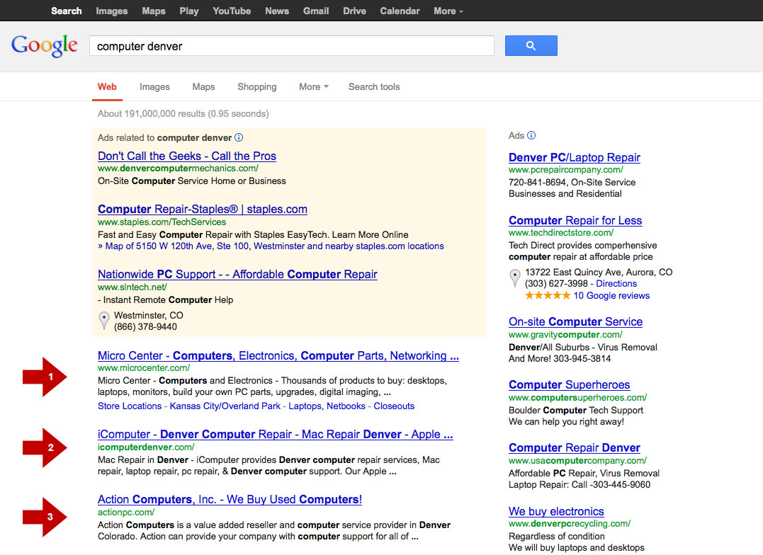

*According to Google, 97 percent of consumers search for* ***local*** *businesses online. The top 10 organic (non-paid) search results get 95 percent of the clicks.*

First, a look at the numbers. According to recent poll data from the Pew Internet and American Life Project, 92 percent of adult Internet users in the U.S. use a search engine (e.g. Google, Bing) to find information online—with the majority of this group performing keyword searches on a regular basis.

When you look at educated and affluent individuals, search engine use climbs to as high as 98 percent.

These statistics simply underline what you and I already know:

**Search is King**.

Everyone who has access to the Internet uses a search engine to find relevant and useful information, and according to Google’s own data, 97 percent of consumers search for **local** businesses online.

### Got visibility?

The upshot of these facts is clear: If you want visibility for your business, you need visibility in the search engines, particularly Google.

Search isn’t just king—it’s a kingmaker too. High visibility in Google can mean more website traffic, more customers and referrals, more sales activity, and more profit for your business.

And for those business owners in hyper-competitive markets, search-engine visibility can be the difference between being an unknown also-ran and being the Top Dog.

### The good, the bad and the ugly: there for all to see

But visibility is a double-edged sword. Customer reviews of your business are visible too.

What if some of these reviews are negative?

What if they’re *scathing*?

Well, the bad news is they can haunt your business for years and have a crushing impact on your bottom line.

On the flip side, good reviews can fuel positive word of mouth and generate referral traffic like you’ve never seen!

### Ranking matters

Here’s what we know about how people use search engines: after entering a keyword into Google and being presented with pages and pages of blue text links, consumers generally don’t dive very deeply into the results (95.91 percent of all clicks occur on page one).

And of page one results, people tend to focus on the top three. According to an Optify study, the top three positions for any given term account for nearly 60 percent (58.5) of the traffic. The top result alone commands an average click-through rate (CTR) of 36.4 percent.

So it’s not enough to be “on Google.” If you want to take advantage of the popularity of search, your website needs to be listed at the top of the page and above the “scroll line” for the search terms relevant to your business.

## 2. Social

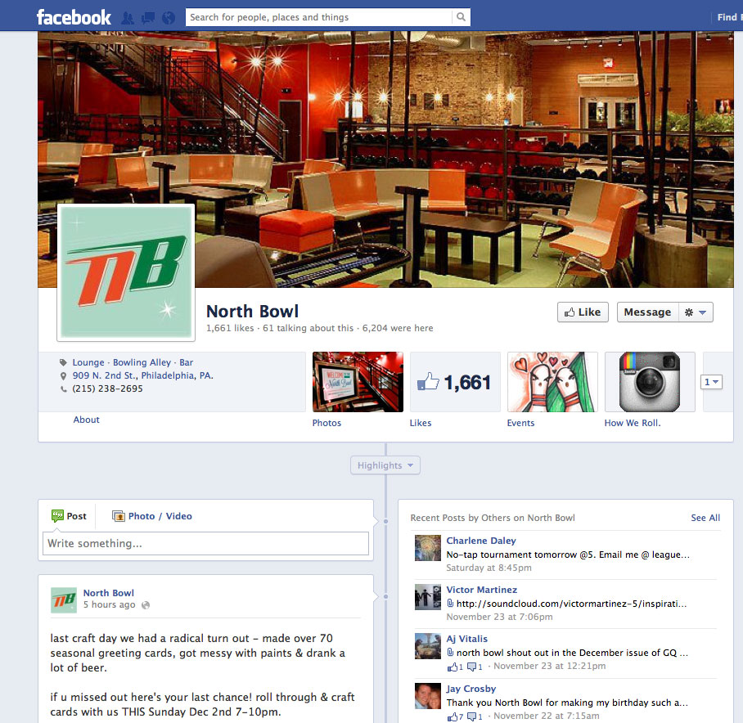

*Small businesses have (finally) embraced social media. According to HubSpot, 90 percent of small businesses are on Facebook, and 66 percent of them are spending more time on social media than they did a year ago.*

We’ve all heard enough hype about social media to last a lifetime (or two). But there’s a good reason, because there’s actually something to the hype.

The social web has truly been a game changer.

### Suddenly the norm

And the rapid rise of social media is pretty breathtaking.

Just think: Facebook grew from a curiosity in a Harvard dormitory to a global force with over 1,000,000,000 users … in less than a decade.

Facebook seems like old news now—a presence in our lives that we take for granted—but it’s worth remembering how recently this shift has taken place.

Study: 59 percent of U.S. consumers use social media to vent about customer care frustrations.

### Not just for kids

A common misunderstanding that small businesses have is that Facebook and other networks are just for kids, and thus their target market isn’t represented demographically on the site.

But the stats tell another story—the opposite story, in fact.

In the U.S., almost two-thirds of all Facebook users are over the age of 35. Recent Pew research reveals that **two-thirds** of U.S. adults use social networking sites like Facebook and Twitter.

### High engagement

People aren’t just ON social networks. They’re GLUED to them.

The average U.S. Facebook user spends a whopping **7 hours and 46 minutes on the site each month**.

That’s a full 15.5 minutes the average American spends on Facebook every single day!

The upshot of all of these numbers is pretty straightforward, but I’ll spell it out just in case:

***Your customers are on Facebook.***

They spend a LOT of time there. They’re sharing, tweeting, liking, pinning, friending, starring, following, fanning, posting, hash tagging, uploading, retweeting … you name it.

So if you want to reach them, capture their attention and make a pitch for your services before your competitors do … you’ve got to at least meet them halfway.

### Sharing experiences … and frustrations

People are taking to the web to share their experiences with brands, and what they’re sharing with their friends and family members isn’t always flattering …

According to a study from the [Society for Communications Research](http://sncr.org/sites/default/files/customer-care-study_0.pdf), 59 percent of U.S. consumers are using social media to **vent** about customer care frustrations. This isn’t just happening on Facebook, but on sites like Angie’s List, Yelp, Google+ Local and others. According to research from Deloitte & Touche, **7 in 10** who read reviews **share** them with friends, family and colleagues, amplifying the impact of these comments even further.

More and more businesses are beginning to realize that, while they can’t control what people say online, they can (and should) monitor and contribute to the conversation in an effort to influence the overall tenor.

They’re realizing that having a **proactive online presence** that’s focused on **adding value to the customer experience** is the surest way to grow and preserve their brand reputation—and protect themselves from the stray musings of a few unhappy souls.

### Keeping pace with buyer expectations

Another big reason to get involved in social media is that you have to do it to **stay relevant**.

Your buyers expect it, and if you fall short of their expectations, they’ll be more likely to spend their money with the guy down the street.

Even way back in 2008, a Cone Business study on social media found that **93 percent of customers expected companies to have a presence on social channels**, and **85 percent expected companies to interact with them on those social channels**.

That figure has only grown as the social media era has matured.

You can either join the conversation or let your competitors do all the talking.

It’s up to you!

## 3. Mobile (“The really, really big one”)



*According to research from Mobile Marketer, 70 percent of all mobile searches result in action within one hour!*

Look around you: You'll see a steady stream of consumers surfing the web on smartphones, iPads, Nooks, and Kindles.

And this is a trend that's hardly slowing.

It’s almost impossible to overestimate the impact of the mobile computing revolution.

In fact, the proliferation of cellphones, smartphones, e-readers and tablet PCs might be one of the most **underestimated** and **under-hyped** shifts in business today.

Today, 87 percent of Americans have mobile phones. It’s their No. 1 most-used technology device, with 73 percent saying so versus only 58 percent saying it’s their desktop PC.

In their recent Mobile Internet Report, Morgan Stanley projects that mobile browsing will outpace desktop-based access within 3–5 years.

When you pause to consider what these newfangled devices are capable of, and how quickly they emerged from high-priced novelties to ever-present, “can’t live without them”[1] gadgets … it’s pretty unbelievable.

Marc Andreessen, co-creator of Netscape, the first widely used web browser, adds some helpful perspective: “We have never lived in a time with the opportunity to put a computer in the pocket of 5 billion people. Practically everyone is going to have a general purpose computer in their pocket, it’s so easy to underestimate that, that has got to be ***the really, really big one***.”

A recent article in the [Economist](http://www.economist.com/blogs/freeexchange/2012/04/general-purpose-technologies) adds this:

The potential of the smartphone age is deceptive. We look around and see more people talking on phones in more places and playing Draw Something when they’re bored. This is just the beginning. In time, business models, infrastructure, legal environments, and social norms will evolve, and the world will become a very different and dramatically more productive place.

### The revolution will be mobilized

It’s clear that the future of the web is tied to smartphones and tablets and other mobile devices. More and more, people who visit your website will do so from a small-screened device instead of a hulking desktop or laptop.

What does that mean to you, the local business owner?

*An Asymco study found that people have adopted mobile phone technology faster than almost any other household technology.*

It means that if you want an effective web presence that supports your business goals, you need to have a website that supports a multitude of platforms, specifically the smartphone.

In fact, a study from Google found that that 6 in 10 mobile users will leave a website if it’s not optimized for small screens.

If your business's site looks cramped, cluttered, or illegible when viewed on a tablet or smartphone, you run the very real risk of turning away your most valuable asset: your customers.

### In a weak economy, mobile matters

Think this “mobile” stuff is much ado about nothing? Let’s put this into perspective …

The economic recovery is a sluggish one. People are still worrying about losing their jobs. Millions of homeowners owe more on their mortgage loans than what their homes are worth. Credit-card debt continues to weigh down U.S. households.

These are challenging times for consumers. As a business owner, you don't want to give them any more reasons not to buy your products or services. Further, you don’t want to add any additional friction to the process of buying your products and services!

A streamlined website for mobile is a new must-have. Particularly when you consider that people with smartphones are still turning to search engines to look for information.

### Search to purchase

What’s more, studies show that when people use their smartphones to search for information, they’re more apt to take immediate action. They search from where they are and go immediately to what they find.

According to research from Mobile Marketer, 70 percent of all mobile searches result in action *within one hour!*

#### How does your website look and perform on a small screen? What kind of experience are you providing to would-be buyers?

[ ] Good user experience

[ ] So-so user experience

[ ] Poor user experience

## What all of this means to YOU!

Alright, readers, let’s have a show of hands:

* How many of you search online before deciding what businesses to buy from?
* How many of you choose a company based on the recommendations you heard from friends over social media?
* How many of you carry a smartphone with you at all times?

We all do!

And again, these trends are only accelerating.

As much as we might wish they’d go away and let us continue with business as usual … the search/social/mobile paradigm is not going anywhere. It’s here to stay.

***The important thing now is to ask the hard questions and seek out the answers—even if they shake things up a bit:***

* How do these changes impact the way consumers interact with my business?
* How do these changes impact my business’s growth?
* How do these changes impact the way I approach the marketing of my business?

# Dramatic Change Calls For … A Renewed Focus on the Fundamentals!

Given all of these revolutionary changes we’ve discussed—search, social and mobile—you might be worried that you are going to have to make drastic, revolutionary changes in your business.

That’s not necessarily the case.

Our experience shows that ***there are four key marketing systems that need to be optimized in order to maximize growth*** in today’s wired, always-on and hyper-competitive marketplace.

The marketing systems we’re about to present aren’t even new!

They’re not hifalutin’ gimmicks that were cooked up in the ivory tower or by some pie-in-the-sky TED-talk guru.

***They’re proven concepts that have been tested, re-tested and tested again in the marketplace.***

Now, sure, some of the tactics have changed, but the strategies themselves haven’t.

As it happens, these four essential areas all start with the letter “R.”

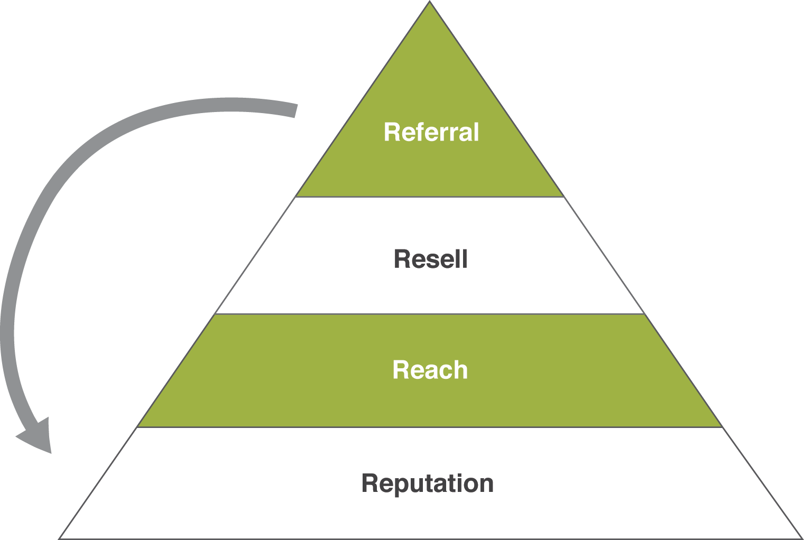

* **Reputation**
* **Reach**
* **Resell**
* **Referral**

These are the four things *every* business needs to plan for and optimize to maximize their growth potential.

Data shows, and my experience proves, that ***each of these can account for about 25 percent growth on their own, and combined have a compounding effect that can ignite growth to 100 percent or more***.

Let’s briefly run through each element and explore how maximizing these 4 R’s could significantly impact growth at your business.

## R1: Reputation

What are you doing to proactively manage, protect and monetize your most valuable asset—your reputation?

The first R is **reputation**. As we discussed earlier, it has never been easier for potential customers to find out what others think about your business. This is both good and bad (depending on what people find).

As you know, nowadays people search online before they buy. We know that people put a lot of stock in what they find and read online. In fact, a recent Nielsen study shows that 74 percent of U.S. consumers choose to do business based on online feedback—even when it’s feedback from total strangers!

According to [Nielsen's](http://www.google.com/url?q=http%3A%2F%2Fblog.nielsen.com%2Fnielsenwire%2Fconsumer%2Fglobal-advertising-consumers-trust-real-friends-and-virtual-strangers-the-most%2F&sa=D&sntz=1&usg=AFQjCNH0K1TyqtzUdgY4lKxJELAscGOv3A) summary of their poll data, recommendations from personal acquaintances and opinions posted by consumers online are “the most trusted forms of advertising.”

**Look who’s talking (about you)**

A sample of who’s talking about your business:

* Customers
* Prospects
* Competitors
* Disgruntled employees
* Ex spouses
* Former business partners, investors
* Trolls (the permanently aggrieved)

This probably isn’t anything new to you, and there’s a decent chance that, like most of the businesses I talk to, you are not very pleased about some of the things people have written about your business!

This brings up a larger point:

Whether it is positive or negative in tone, **most of the content about your business that is available online is not even being created by you anymore!**

Consumers are critics and publishers now.They all carry tiny “printing presses” in their pockets!

### Reputation: more important than ever

To be sure, businesses have always relied on their reputation.

But the stakes are even higher today because of how easy it is for consumers to find information about local companies before they buy.

What’s more, as we’ve already discussed, negative reviews can get lodged in the search results, hanging like an albatross around your neck and dragging down sales.

#### Are you "Googleable"? How many pages of Google are you on? (You may include Search, Maps, and Google+ Local citations in your answer)

[ ] Don’t know

[ ] 0

[ ] 1

[ ] 2–5

[ ] 6+

Study: 90 percent of consumers online trust recommendations from people they know; seventy percent trust opinions of unknown users.

## R2: Reach

What are you doing to ensure that more people know about you today than yesterday?

The second R is **reach**. It’s my experience that ***a business that wants to grow needs to make sure that more people know about it today than did yesterday***.

If you’re not meeting new people and telling them about your products and services, you’re not developing a pipeline of potential new customers and you are going to see fewer sales in the future as a result.

This sounds pretty obvious, I know. But I’m always surprised when I talk to local business owners and ask them about their promotional efforts.

***When I look at the pipeline-filling activities of local businesses, I see mostly a scattershot approach***.

A campaign here and there … with only a vague idea on whether they are getting a positive return on their investment.

No wonder so many businesses become skeptical of marketing:

***They’re doing it wrong!***

Very rarely do I see coordinated, systematic and metrics-driven efforts to reach a wider audience and drive more prospects (i.e. people who are interested in what you’re selling) through the front door.

But this kind of focused, ongoing and intentional approach is exactly what’s necessary to reach more qualified prospects in a cost-effective—not to mention satisfying!—manner.

***A once-in-awhile, ad hoc marketing strategy is not going to get the results you need to achieve consistent business growth.***

#### Do you have a method to build a continually growing prospect/client email list?

[ ] Yes

[ ] No

[ ] We don’t have a list

## R3: Resell

What are you doing to upsell, cross sell and repeat sell to maximize the lifetime value of your customer base?

The third R is **resell**. Once you've done all of the hard and often costly work of getting a customer, you need to make sure to maximize the lifetime value, or LTV, of that customer.

Whatever metaphor you want to use … mining your backyard … picking the low hanging fruit … the point is the same:

***It makes more sense (both financially and from an efficiency standpoint) to fully capitalize on your existing customer base than to be constantly on the hunt for new customers.***

The more value you can generate from each customer, the less you have to spend on marketing, which means you can increase your profit margins and/or reinvest the savings into your products and services—in the process making your business even more attractive to your customers!

In practice, this can mean increasing the dollar value of each transaction or increasing the frequency that customers buy, either by offering add-on services or upsells or cross-sells.

McDonald’s offers the classic example: ‘Do you want fries with that?’ ‘Do you want to supersize your order?’

These days there are so many cost effective and trackable ways to bring customers back to your business.

To give you just one example, consider SMS coupon campaigns. With monthly costs lower than $30 to send 1000 text messages, and average redemption rates of 20 percent or more, it potentially costs less than 30 cents per customer in your door!

Despite having easy access to new and cool tools, most business in our area are leaving money on the table because they’re not maximizing the resell potential of each customer.

#### Do you ethically (but effectively) prepare buyers from their very first purchasing experience with you to keep coming back to purchase over and over again?

[ ] No

[ ] Yes

[ ] Not sure

## R4: Referral

What are you doing to use your successful relationships to create new, organic opportunities so that you can spend less and make more?

The fourth R is **referral**.

Since you’re doing such a great job taking care of your customers and keeping them happy, the next best thing you can do is set up systems to maximize the benefit you get from them, right? So that they are doing the marketing for you!

Well, it’s well known that ***if you just leave it up to people to do referrals for you, very few will—even if they are very happy with you***.

***You have to make it very easy—almost effortless—for your happy customers to refer your business*** if you really want to maximize the referrals you generate from them.

A study from Lee Resource Inc. found that attracting a new customer can cost five times as much as keeping an existing one.

### Referrals make great customers

We all want referrals because they help us save money on marketing, right?

Well, there’s even more to gain from referrals than cost savings:

According to a case study noted in the Harvard Business Review, customers that come from referrals are, on average, about 18 percent more likely than others to stay with a company and they generate 16 percent more in profits!

And according to several case studies reported on by the website TechCrunch:

***Friends referred by friends make better customers.***

**They spend more** (a 2x higher estimated lifetime value than customers from all other channels at One Kings Lane); **convert better** (75 percent higher conversion than renters from other marketing channels at Rent the Runway); and **shop faster** (they make their first purchase after joining twice as quickly than referrals from other channels at Trendyol).

### Why are referrals so powerful?

Because they channel the power of **social proof**. Social proof is a fancy way of saying that we humans are easily influenced by each other.

We’re pack animals.

When a member of our pack (family) or tribe (social circle) recommends a product or service, we take that recommendation very seriously.

Similarly, when someone in a position of power, prestige or authority recommends something, we are very **quick to act** on that recommendation.

You see the applied power of social proof everywhere: in TV ads, when you see a celebrity endorsing a product; on the radio, when the person hosting the pledge drive tells listeners that so-and-so donated $50 to NPR; on the back of a novel you’re reading, when you see testimonials from other notable authors; and on the web, when you visit sites like Yelp.com to read consumer reviews of local restaurants.

### Moving from passive to active, ad hoc to systematic

Almost without fail, ***most businesses I talk to have no clear referral generation system***.

They essentially think that referrals are something that you simply wait and hope for … but ***the reality is that referrals don’t just happen, you have to go out and get them!***

And if you’re going to spend the time collecting them, you need a system that effectively channels your efforts into tangible results.

#### How many formal, written referral-generating systems do you currently have with prospects or potential partners? (Check one)

[ ] 0

[ ] 1

[ ] 2–5

[ ] 6+

## What are you missing?

Now, the problem is that most businesses are operating without even being aware of these changes or marketing systems, and how it is impacting their business.

Let me show you some examples …

First, if you aren’t effectively and proactively managing your reputation, you aren’t aware of comments like this being made about your business:

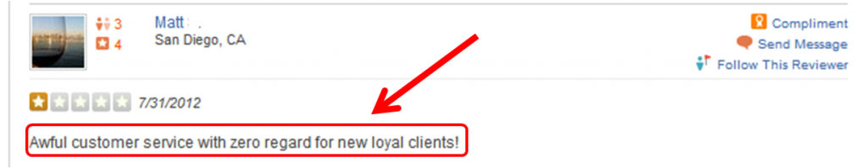

*Ouch. That hurts. Comments like these will negatively impact how others view your business in the marketplace. According to Nielsen, user reviews are “the most trusted form of advertising.”*

Or, you have people looking for your business on their mobile phones, and your website is showing up like this:

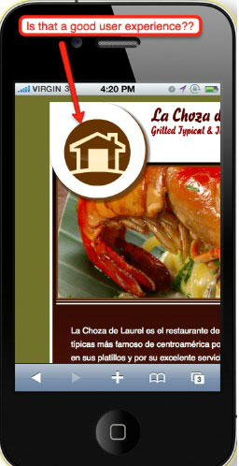

*No one has fingers small enough (or patience long enough) to navigate this web page. A study from Google found that 60 percent of users will leave a website if it’s not optimized for mobile.*

While your competitors’ mobile website is showing up like this:

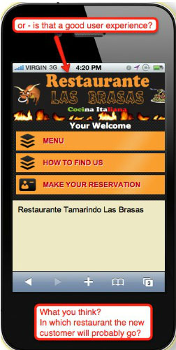

*People will stay on your competitor’s website if it’s optimized for a small touchscreen.*

So, how can we address some of these things?

Let me share some ideas … I obviously can’t give you all of them in the space of this small book, but let me share a few:

* Control your own reviews with your own review site
* Create a separate mobile site for your business that is optimized for mobile
* Reach more people more cost-effectively and with greater targeting using Facebook ads

## Is your business being left behind?

Now, if you fall into the category of businesses that are not proactively working with these technology changes and marketing systems, **you are only going to see things get worse over time**.

These changes, though recent, are now a permanent part of the competitive landscape.

***The gap between the businesses that “get it” and those that don’t is widening at an accelerating pace***.

You can look at any industry and see examples of the handful of businesses that are really pulling away from the pack, and those that are falling behind.

## It’s time to go ‘all-in’

Do you have someone that is helping your business in these areas?

Or are you kidding yourself into thinking that you are going to try to do this by yourself or with the very part-time effort of one of your employees that has no marketing background?

That’s not going to cut it.

Do you watch “Parks and Recreation”? to paraphrase the wise Ron Swanson, ***you can’t half-ass two things. You’ve got to whole-ass one thing.***

If you’re struggling to fit everything into your calendar already (most business owners I talk to are), you’re probably not going have the bandwidth to optimize the four R’s. Either something else has to give, or you need to enlist a friendly expert to help you!

## Answer the call

Get this: according to data from Google, **61 percent of local searches on a mobile phone result in a phone call**.

Are you ready, both literally and figuratively, to answer that call?

Or are you going to let ring until one of your competitors picks up the phone?

Are you ready to answer the call? Or are you going to let ring until one of your competitors picks up the phone?

## If you’re ready to make a shift …

You may realize that you need to make a change, that you aren’t growing like you should, that your current approach to marketing is not working, and that you are committed to getting past your current income limits.

If so, I would be interested in talking with you to see if there is potentially a good fit to work together.

However, I must say upfront that I only work with one business in each vertical per zip code so I can give them all of my knowledge and experience without having to worry about conflict with another client.

And we are particular about who we work with.

We work with businesses that are already successful and are looking for strategic ways to get FAR MORE successful.

We work with clients that have the mindset and resources to handle the level of growth that is possible to achieve.

**What to do next**

If you’ve seen the benefit of what you’ve read in these pages, then I’d encourage you to contact us immediately. From there, we will set up a follow up phone call interview to see if we are a good fit to work together.

This phone conversation is not a guarantee we will work together. But it is a necessary first step if we are to work toward achieving the growth you’re capable of!

**How to contact us**

* Head on over to our website and send us a note that you are interested in a conversation with one of our Marketing Consultants and we will get you setup as soon as we have an open slot.

We look forward to hearing from you!

# What Are You Doing to Optimize the Four R’s?

**Reputation**: What are you doing to proactively manage, protect and monetize your most valuable asset—your reputation?

___________________________________________________________________________

___________________________________________________________________________

___________________________________________________________________________

**Reach**: What are you doing to ensure that more people know about you today than yesterday?

___________________________________________________________________________

___________________________________________________________________________

___________________________________________________________________________

**Resell**: What are you doing to upsell, cross sell and repeat sell to maximize the lifetime value of your customer base?

___________________________________________________________________________

___________________________________________________________________________

___________________________________________________________________________

**Referral**: What are you doing to use your successful relationships to create new, organic opportunities so that you can spend less and make more?

___________________________________________________________________________

___________________________________________________________________________

1. To illustrate this point, consider this statistic from Unisys: It takes 26 hours for the average person to report a lost wallet. It takes only 68 minutes for them to report a lost phone.